EMF Pollution from Living Near Power Lines
Electromagnetic radiation from high voltage power lines are something that can affect the health of people in urban and rural communities. Strong, artificial EMFs that radiate from power lines can scramble and interfere with your body’s natural EMF, harming everything from your sleep cycles and stress levels to your immune response and DNA!

Is there a safe living distance from power lines?
Hundreds of studies worldwide have shown that living next to high voltage power lines and other parts of the power transmission network increases your risk of cancer and other health problems.
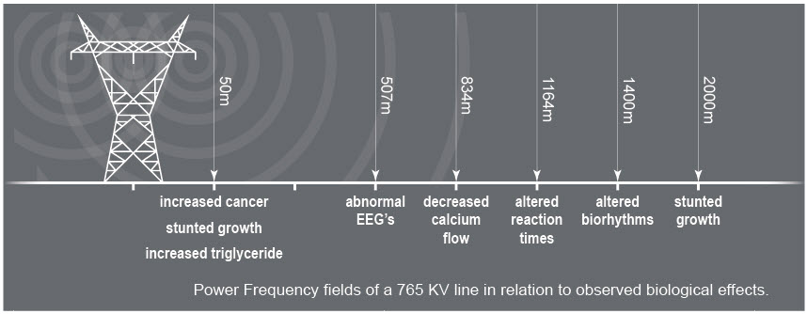
The closer you are the more you are bombarded with dangerous EMFs. The electrical power grid uses a “step down” system of distribution, highest near the generating station and substations, lowest at the end.
Increasingly, the medical community is recognizing the danger to health these power lines can cause. For example, a variety of studies suggests that living close to high-voltage power lines can increase the incidence of several kinds of cancer, as well as other diseases.

Health Risks and Power Lines.
According to research and publications put out by the World Health Organization (WHO), EMF such as those from power lines, can cause:
- Headaches
- Fatigue
- Anxiety
- Insomnia
- Prickling and/or burning skin
- Rashes
- Muscle pain
Protecting yourself and your family

Power lines are virtually everywhere. However, SafeSpace offers a range of effective, affordable products that can help you protect yourself and your loved ones against the dangers from hallmarks of the modern world.

